|  |  |
| --- | --- |
| **Student Name** | **Student ID** |
| Sudhir Joshi | 30101044 |
| Chandan Plaha | 30096799 |



2013

Software Requirements Specification ( SRS)

**Project: Flash Maze Game**

Table of Contents

1 INTRODUCTION 4

2 PROJECT OVERVIEW 4

2.1 PURPOSE 4

2.2 CLIENT 4

2.3 Business Context 4

2.1 SCOPE 5

2.2 User Characteristics 5

2.3 Acceptance criteria - 5

3.0 Assumption, Dependencies, Constraints 5

3.1 Dependencies 6

3.2 Constraints 6

4.0 Abbreviations 6

5.0 HIGH CONCEPT STATEMENT 7

5.1 Features 7

5.2 Overview 8

Player Motivation 8

Genre 8

Target market 8

Competition 8

Unique Selling Points 8

Target Hardware 8

Design Goals 9

Visibility 9

Simplicity 9

Further Information 9

Sales pitch 9

6.0 Core storyline 10

7.0 Use Case Diagram 10

7.1 Use case – 1 Login and manage profile 11

7.2 UC-2: instructions 12

7.3 UC-3: Game menu and welcome message 13

Game Levels 14

7.4 UC-4: play game 14

7.5 UC-5: sound level 15

7.6 UC-6: contact us form 16

7.7 Use case-7 Administer level 16

8 FUNCTIONAL REQUIREMENTS 17

9 Functional requirements in details 18

10 Non-Functional Requirements 20

10.2 Non-functional Requirements 20

10.3 Performance Requirements 21

10.4 Logical Data Requirements 21

10.5 User Requirements 21

10.6 Information Management Requirements 21

10.7 Systems Requirements 22

Performance Requirement 22

Quality Requirements 22

Interfaces 22

Software Requirements 22

Client-side 22

Server-side 22

10.8 Database Requirements: 22

11 Data descriptions 23

11.2 Dataflow diagram 25

11.3 Data flow diagram (DFD-1) 25

11.4 Data flow diagram (DFD-2) 26

Software Requirements 27

Client-side 27

Server-side 27

11.5 Database Requirements: 28

8.2 Description of textures 28

12 Reference 30

13 Revision History 31

# INTRODUCTION

The purpose of the project is to create a Flash maze game for kids, where in the idea is to provide personalized timetables to the students .As of now there will be three stages in game and before starting game player has to input their Names so that score will be stored .The game shall provide different facilities to the Player.

User have three level which they can choose by themselves or else user has to complete easy level and will moved to medium level and the final hard level. There will be time frame in which they have to complete. As game is based for kids, so the character we will be using will be cartoons. Main objective of game is to find the way out or else we can say have to reach final point from start on given time without crashing with any obstacles.

# PROJECT OVERVIEW

## PURPOSE

The purpose of this Software Requirements Specification (SRS) is to provide a design of Flash maze game for kids. This document will provide the Client and the user with a basic understanding about the game’s performance and its goals.

## CLIENT

The audience of this document will be the client (Hari Kiran Vege) and its user (gamers).

Hari Kiran Vege Head of IT department of Australian Technical and Management College (ATMC) who have wide experience of Programming, Database and all.

## Business Context

The development of this game is for the first project in Project 1 class at ATMC Melbourne (University of Ballarat)

## SCOPE

We are developing Maze game in flash.

The project will be developed using Flash CSS with AS3.

We are going to program character to move through the mazes in the game.

Our final product will deliver requirement, design documents and user document, codes and an executable file.

## User Characteristics

**Devices**: Keyboard

**Game Mode**: Single Player Mode.

**Action**: Walk, Win/Loose, Collect Gems, Hit and fail

**Location**: Maze

## Acceptance criteria -

User should able to enter the name.

Have to complete first level in a given time frame

# Assumption, Dependencies, Constraints

## Dependencies

* + The speed of game will vary upon different CPU
  + Flash player or its plugins is necessary

## Constraints

* A prototype presentation of the complete application must be delivered and operational at the end of the semester (week 12)

# Abbreviations

|  |  |
| --- | --- |
|  |  |
| SRS | System Requirement Specifications |
| PM | Project Manager |
| SCD | System Context Diagram |
| DFD | Data Flow Diagram |
| ERD | Entity Relationship Diagram |
| UC | Use Case |
| FR | Functional Requirements |
| NFR | Non Functional Requirements |

# HIGH CONCEPT STATEMENT

Family guy maze game is a challenging and addictive puzzler game that teases everybody’s brain. Strategically pop the character to find out a way through the maze, each character passes the level add one point. The strategy is complete given maze in the given time to compete in the next level.

## Features

Family guy is a puzzle single player game that gives every player the thrill of creating a strategy in order to complete all the three levels

* The game has a pleasant view, as bright colors have been used
* It has 3 levels, with increased difficulty (demo version)
* The game starts with by entering a name of the player.
* score and will be added as the level increases
* if a given time frame finishes game finishes and player looses
* game can be played with a keyboard and also have mouse pointer interface
* • The strategy is very important in order to finish all the three levels
* The player gains score after each level
* once all the level finishes games finishes
* if player loses at level 3 game starts from scratch
* Home screen features cartoon jpeg images

## Overview

Player Motivation

The player has to develop the right strategy in order to advance to the next level. As every level increase game time frame will be cut down. Player will be motivated by giving those scores.

### Genre

Family guy game will be classified as a puzzle game, falling under the maze-logic subgenre,

As it is a brainteaser for every player. The game can be played by only one person at a

Time, and it is designed, like any other puzzle games, to fill the bits of free time from

People’s schedule (i.e. Commuting, breaks).

Target market

The target market for this game is very wide. It can be played by adults as well as by

Children’s, no matter their motor and cognitive skills, attention spans, or linguistic

Abilities. It targets any individual that enjoys playing this genre of game but it is mainly focused for the kids as this game is based on cartoon named Family Guy.

### Co**mpetition**

Family guy gives competition to same level flash games

### Unique Selling Points

Version 1 will be free

Small size game

Even age level between 4 -6 can also play the game

### Target Hardware

This game been developed mainly for windows which require flash plugins to play the game.

### Design Goals

The graphic elements are made out of bright colors that can appeal to any age category (children and adults).On each level the player is welcomed by new scenery. The three cartoon images will include in the background of all three levels.

### Visibility

The camera model, players being able to view the entire window. The graphical elements, specific to level they are playing, in the same frame.

### Simplicity

Very simple control system, players need to touch the keyboard arrow they wish to move, making this an easy game to learn and play.

### Further Information

Family guy Maze game is a linear, objective driven type of game. The player is lead through a fixed route, in which progress becomes harder and harder.

### Sales pitch

First version of game will be free

Designed for kids

Brain exercise

# Core storyline

Peter the name of character from the game family guy. Who has moved into a new town and while coming from his job he gets lost on the way, so he has to find a way to his home by going through series of maze (zig-zag)

# Use Case Diagram

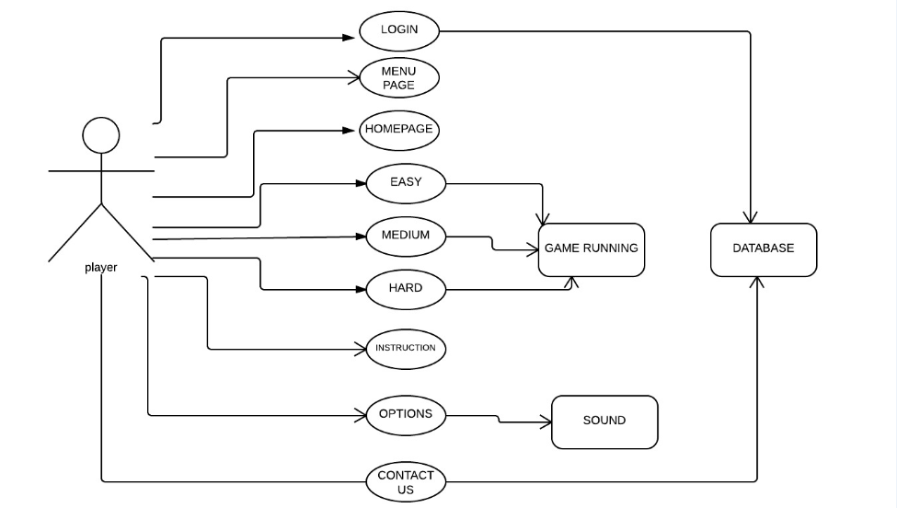

# 7.1 Use case – 1 Login and manage profile

|  |  |
| --- | --- |
| **Name** | UC-1: Manage Profile |
| **Summary** | Player can change information into their profiles and Admin will allow them to make changes, which include player name and character |
| **Actor** | All Users |
| **Pre-Condition** | Profile and record must exist |
| **Basic course of Event** | 1. User opens the game in the flash player 2. The system displays enter the name box 3. User will input the necessary data into the box.   System will update the record . |
| **Post- Condition** | 1. User receives the notification that he has entered in the game |
|  |  |

user

Enter the name

# 

# UC-2: instructions

|  |  |
| --- | --- |
| **Name** | UC-2: instruction box |
| **Summary** | User can look for the instructions by clicking instruction button |
| **Actor** | User |
| **Pre-Condition** | Instruction box will be displayed |
| **Basic course of Event** | 1. User can memorize the controls 2. User can go back to enter the name box |
| **Post- Condition** | Clicking on back button player will be left onto enter the name or manage profile box |
|  |  |

User

Instructions provided

# UC-3: Game menu and welcome message

|  |  |
| --- | --- |
| **Name** | UC-3:welcome message and game menu |
| **Summary** | Player can check his profile name and game menu( image no-001 in appendix) will be displayed |
| **Actor** | Game |
| **Pre-Condition** | Player must choose the game level to play the game |
| **Basic course of Event** | 1. The player login to system and check status of his profile 2. The system displays GUI for the game menu 3. Player clicks on the game and start playing.   System will show all the game menu and options |
| **Post- Condition** | 1. Result successfully shown to player |
|  |  |

User

Profile name & Menu

# Game Levels

# UC-4: play game

|  |  |
| --- | --- |
| **Name** | UC-4: game levels |
| **Summary** | Player can compete in any level |
| **Rationale** | Player wants to complete given level |
| **Actor** | Player and a game itself |
| **Pre-Condition** | Employer must have a reasonable task |
| **Basic course of Event** | 1. Employer access the required level to play the game. 2. System will show the appropriate time frames and scores. 3. Player must compete in a given condition. 4. System will save the scores. |
| **Post- Condition** | If user wins can continue another level if not can retry |

User

Game play

# UC-5: sound level

|  |  |
| --- | --- |
| **Name** | UC-5: sound level |
| **Summary** | Player can change the sound settings. |
| **Rationale** | If sounds will be turn off game must turn off the sound and vice versa |
| **Actor** | Player |
| **Pre-Condition** | There must be a sound options button |
| **Basic course of Event** | 1. Player can turn on the sound 2. Player can turn off the sound 3. System must respond |
| **Post- Condition** | Sound setting will becomes effective |

User

Sounds level

# 

# UC-6: contact us form

|  |  |
| --- | --- |
| **Name** | UC-6: contact us and friends |
| **Summary** | Player can contact developers and his friends via contact us form |
|  |  |
| **Actor** | Player |
| **Pre-Condition** | Employer must enter a valid email address and message |
| **Basic course of Event** | 1. The user must open a contact us form 2. Must enter a valid email address 3. System will show the delivery status |
| **Post- Condition** | Player will see the message delivery status |

User

Contact us form

# Use case-7 Administer level

|  |  |
| --- | --- |
| **Name** | Handle users |
| **Summary** | Admin have to store all scores in the database |
|  |  |
| **Actor** | Admin |
| **Pre-Condition** | Profile and record must records must be saved |
| **Basic course of Event** | 1-scores will be scored in the database  2-user can access scores  3-user can send scores to friends |
| **Post- Condition** | Player can access scores at any given time |

# FUNCTIONAL REQUIREMENTS

ACCESS TO GAME ENTER THE GAME APP

FLASH PLAYER

GAME APPLICATION

USER

ACCESS TO GAME RESPONSE

# Functional requirements in details

|  |  |  |  |
| --- | --- | --- | --- |
| **Functional Requirement Id** | **Requirement Name** | **Details of requirement** | **Priority** |
| FR01 | Enter your name to enter the game | The game will provide the user to enter the name to start the game | Optional |
| FR012 | Name entered or name not entered | If user will enter the name .user name will displayed in the welcome message otherwise friend will displayed as a welcome message | Essential |
| FR02 | Instruction | User must click on instruction link so that he can look at the keyboard controls | Essential |
| FR03 | Next | Player must click on next link so that he can enter the main game site and menu . | Essential |
| FR04 | Home | After logging into the game ..game must show user his name if he entered his name in functional id FR01 otherwise **Hello,My friend, welcome to the Game Menu, Please choose one of the level and HAVE FUN! Will be displayed with game menu.** | Essential |
| FR05 | Choose level | User must choose one of the levels from easy –medium-hard from a game menu | Essential |
| FR06 | Easy level | User must enter the game level easy to play the easy level game | Essential |
| FR061 | Level easy game | Player will be given 90 seconds time to compete in a level and will be given scores | Essential |
| FR08 | Level easy complete | If player complete level easy you winner will be displayed otherwise you looser will be displayed | Essential |
| FR09 | Retry | After completing level –easy user can retry by clicking on retry link for as many times he wants to play the game | optional |
| FR010 | Medium level | User must enter the game level medium to play the easy level game | Essential |
| FR011 | Level medium game | Player will be given 60 seconds time to compete in a level and will be given scores | Essential |
| FR012 | Level easy complete | If player complete level medium you winner will be displayed otherwise you looser will be displayed | Essential |
| FR013 | Retry |  | Optional |
| FR014 | Hard level | User must enter the game level hard to play the easy level game | Essential |
| FR015 | Hard level game | Player will be given 45 seconds time to compete in a level and will be given scores | Essential |
| FR016 | Hard level completes | If player complete level hard you winner will be displayed otherwise you looser will be displayed | Essential |
| FR017 | Retry | After completing level –medium user can retry by clicking on retry link for as many times he wants to play the game | Optional |
| FR018 | Sound Options | Player can on/off sound settings by going into options menu | optional |
| FR019 | Contact us form | User can any time login into contact us menu and access to message via email to save scores | Optional |
| FR020 | Submit button | Player must click on submit button to send the email or message | Essential |
| FR021 | Submit button clicked | Game must notify user by displaying message of **message sent** confirming | Essential |
| FR022 | Email a friend | Player can also email a friend his or her high scores | Optional |

# Non-Functional Requirements

## Non-functional Requirements

Non functional requirements are defined as non-core requirements of the system.

|  |  |  |  |
| --- | --- | --- | --- |
| Non-Functional Requirement ID | **Non-Functional Requirement Title** | **Detail of requirement** | **Priority** |
| NFR001 | Usability | Due to the nature of the players, the game needs to be as simply as be | Essential |
| NFR002 | Aesthetics | The look of the game should be simple and use highly contrasting colors for text. The game should be more innovative by looks. | Essential |
| NFR003 | Load time | Flash should be up to date and it any other system should play swf.files | Essential |
| NFR004 | Security | The system should be fully secured to keep data safe. | Essential |
| NFR005 | Privacy | Privacy will not be at highest priority as profile name and scores will be displayed to other users | Not essential |
| NFR006 | Ethics | The game should meet all the ethical requirements . | Essential |

## Performance Requirements

* No specified knowledge required
* Only built for flash versions

## Logical Data Requirements

* Logical Data requirements are AS3 programming, boundary check, hit check and collision check.

## User Requirements

* Use keyboard to control the main character.

## Information Management Requirements

* Management requirements are Time count.

## Systems Requirements

### Performance Requirement

* Reliable CPU.
* Cpu with flash player or flash plugins.
* Must run on Window platform

### Quality Requirements

* Describe requirements for the quality characteristics of the software

### Interfaces

* Flash Player application.

## Software Requirements

### Client-side

* Any flash player capable of supporting flash files

### Server-side

As the Server environment is already determined the software requirements listed are for versions of programs already being used by the hosting environment.

* Adobe css.
* MySQL is needed to store all data.
* Firewall To protect the application from illegal activities.

.

## Database Requirements:

The main requirements of the database is to have all the scores and profile names.

# Data descriptions

### Dataflow diagram

## Data flow diagram (DFD-1)

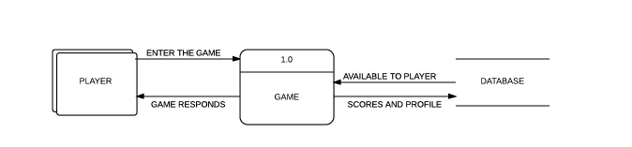

**Basic data flow diagram at all the three levels**

## Data flow diagram (DFD-2)

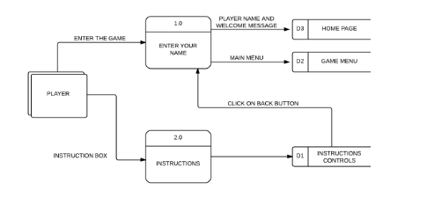

**Data flow diagram at level -1 when player enters a game**

## Data flow diagram (DFD-2)

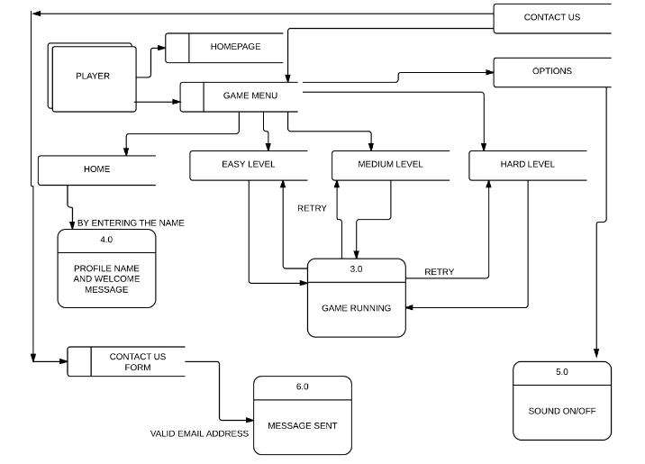

**Data flow diagram of complete system**

## Software Requirements

### Client-side

* Any Web Browser capable of supporting common web standards, e.g. CSS. This includes, but is not limited to: Mozilla Firefox, Microsoft Internet Explorer, Safari, Netscape and Opera.

### Server-side

As the Server environment is already determined the software requirements listed are for versions of programs already being used by the hosting environment.

* PHP v4.3.1 is needed to process all PHP script for the system.
* MySQL is needed to store all data.
* Firewall To protect the application from illegal activities.
* UNIX is used as the UOB-community operating system.

## Database Requirements:

The main requirements of the database is to have all the entities and a place to store data. These can be further will be explained by the ER diagrams and data scheme etc.

# 12.0 Description of textures

A texture map is applied to develop this game, to the surface. Multitexturing is the use of more than one texture at a time in a flash css. In conventional Flash games, in most of the time we use the PNG format for their textures, or JPG if they don't need transparency.

In maze game you can use those as well, of course. Through further stage , however, atf texture offer a great alternative to those formats: ATF textures. Compared to conventional file formats, they have several powerful advantages

# Appendix

  

**GAME CHARACTERS**



**MAIN MENU**

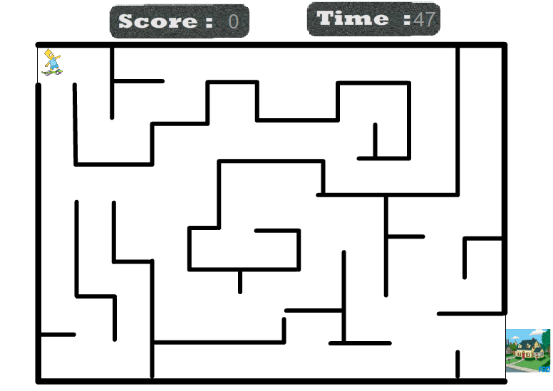

**BASIC DESIGN**

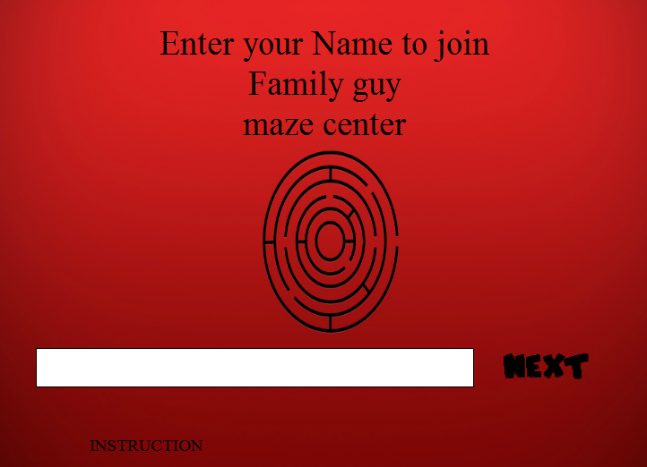

**LOGIN AND INSTRUCTION PAGE**

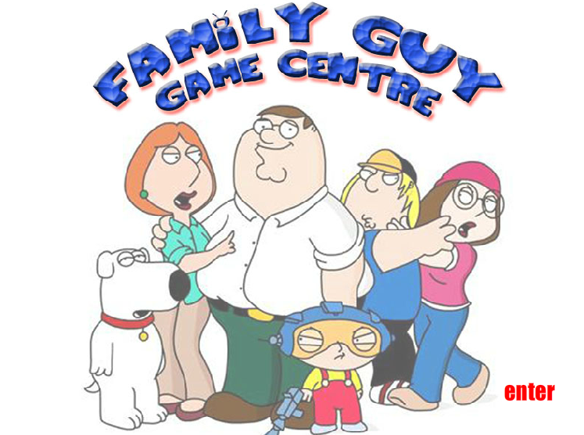

**ENTERING THE GAME**

# Reference

John W. Satzinger, Robert B. Jackson, Stephen D. Burd (2004). *System Analysis and Design in a Changing World* (3rd ed.), Thomson Cource Technology, Boston, Massachusetts, USA.

Ludwig Consulting (2008). *Templates and Guidance. R*etrieved June 6, 2008, from <http://www.jiludwig.com/Template_Guidance.html>

Oregon Government (2008). *Requirements Specification Template.* Retreived June 6, 2008, from <http://www.oregon.gov/DHS/admin/pmo/data/executing_templates/requirements_template_lite.doc>

Schwalbe, K. (2006). Information technology project management, (4th Ed.). Cambridge, MA: Course Technology.

Stephen Cooper (2008). *Software Requirements Specification.* Retrieved June 6, 2008, from <http://www.sju.edu/~scooper/spring01se/SoftwareRequirementsSpecification.htm>

# Revision History

Identify changes to the SRS.

| **Version** | **Date** | **Name** | **Description** |
| --- | --- | --- | --- |
| 1.0 | 10/09/2013 | SRS | Initialisation |
| 2.0 | 18/09/2013 | SRS | Requirements update |
|  |  |  |  |
|  |  |  |  |
|  |  |  |  |
|  |  |  |  |